Task1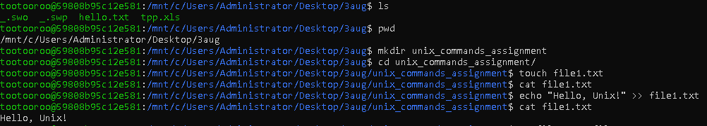

Task 2

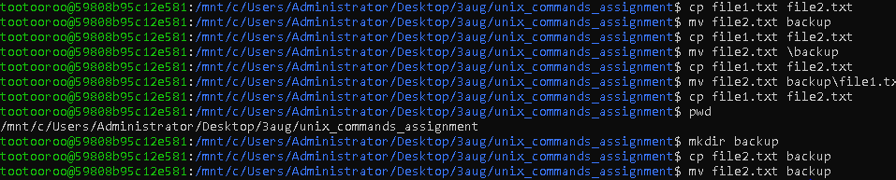

Task 3

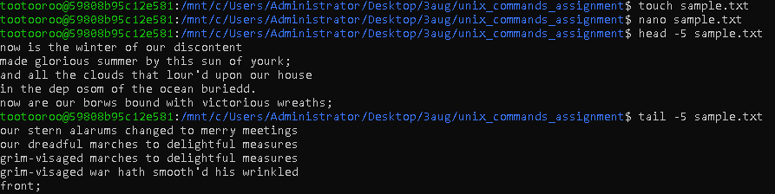

Task 4

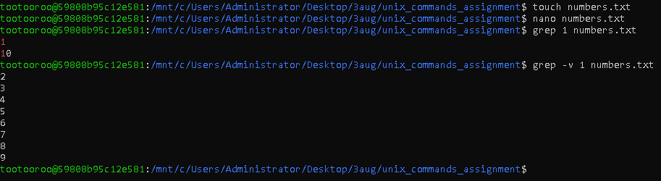

Task 5



Worked with different terminals vim, cmd, gitbash, ubuntu  
Learned about various unix commands viz. Ls, pwd,mkdir,cd, touch,cat, echo, cp, mv, nano, grep, rm